

Dr. Angela, Mills inc.

2023-11-10

Dr. Mills

34172 Stephanie Freeway Suite 575, Lopezfort, MA 49237

Phone: 7470981467

Fax: 3716669195

**Re:** Sharon, Burns

**PHN:** 2709651377

**Birthdate:** 11-Sep-1996

**Address:** 77485 Charles Stream Apt. 196, East Michael, DE 76253

**Patient number:** 5214949356

To Whom It May Concern:

This is a medical letter to state the above patient is pregnant with expected delivery date of 22-Feb-2025. Hoping this information is satisfactory for your requirements.

Thank you.

Sincerely,

Dr. Angela, Mills

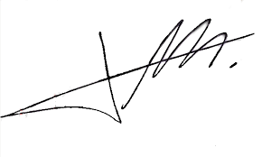

FRCS© NCMP

Clinical Assistant Professor, UBC

Department of Obstetrics and Gynecology SMH